**Class Exercise #5 - File Paths and Links**

Instruction (completing this instruction – 10/50 points):

1. Similar instruction to Class Exercise #1, #2, #3 and #4 instructions.

2. Please use MS Windows 10 Snipping Tool to take screen shot of the following Tasks, **screen shot of the web browser not the HTML code from the video, make sure it is legible and readable screen shot.**

2. Please put your full name in the header.

3. Please do not modify this document to another format, keep as MS Word with .docx.

4. Submit this document to eCampus > Submit Your Assignment Here > Class Exercise #4 Submit Here. Refer to the syllabi for due date.

5. In this assignment you will create one html document:

* Task A – File Paths includes the following files:
  + federal.html
  + state.html
  + city.html
  + neighborhood.html
  + house.html
* Task B – HTML Links: links.html

6. In regards to your index.html page, **link the index page to the all webpages in step #5 above**, like you did for Class Exercise #1, the index.html to basic.html and link back from basic.html to index.html.

I shouldn’t use the back or forward-arrow buttons for navigation.

7. Please place all web pages under the Assignment column in your main index page, provide description to each under the Description column and include the date when you did this, when you link from your index page to these webpages and back to index.html, post your Class Exercise assignment, link it from your index.html page, please use the attribute target = “_blank” inside your anchor element, using FileZilla FTP account information, to your web directory. Please check on the web server to make sure all links are not broken.

8. File Structure – Please organize you file structure appropriately; with only one index.html file at the root of your directory, with several sub directories, ClassExercises, and only one index.html file at this time.

Like this:

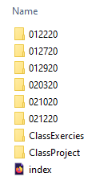

**NOTE**: Your local directory should mirror the same file structure on the FTP web server.

---------------------------------------------------------------------------------------------------------------------------------------

**Two Tasks for this assignment:**

**Task A: File Paths**

**Task B: HTML Links**

---------------------------------------------------------------------------------------------------------------------------------------

**Task A: File Management – Dot Dot Subdirectory**

Recalled my video on the DOS Command,

<https://www.youtube.com/watch?v=_CNsvn-ZfjA>

Please watch again if you haven’t or don’t recalled. The important message is that every time you create a new sub directory, the Windows OS creates two sub directories, one of them is the “ .. subdirectory.”

The . . subdirectory takes you to the parent directory. In the video, the DOS instruction is CD .., means Change Directory to parent directory.

NOTE: You see this in FileZilla as well.

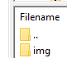

You can click on the .. subdirectory, and this will take you to the parent directory.

------------------------------------------------------------------------------------------------------------------------------------

NOTE: A file path describes the location of a file in a web site's folder structure.

File paths are used when linking to external files like:

* Web pages
* Images
* Style sheets (We will complete this in Boot Strap assignment)
* JavaScripts (We will complete this in JavaScript assignment)

------------------------------------------------------------------------------------------------------------------------------------

There three tasks in this Task A assignment:

1. Write the file path **from** the file **to** an image in a sub directory below or above the file.

2. Write the external file path **from** the file **to** an image linked on our web server.

3. Write the file path for all html pages link back to the main index page.

------------------------------------------------------------------------------------------------------------------------------------

Task A – Download, Uncompressed and Mount.

File Path and Links – Part 1 <https://www.youtube.com/watch?v=P2m1YJPdk9U>

File Path and Links – Part 2 <https://www.youtube.com/watch?v=LaGaiQiHR7Y>

File Path and Links – Part 3 <https://www.youtube.com/watch?v=h7nIYUYFiYE>

NOTE: corrections to link, about 1:50/2:33 minutes into the video, the highlight link to the web server is updated to:

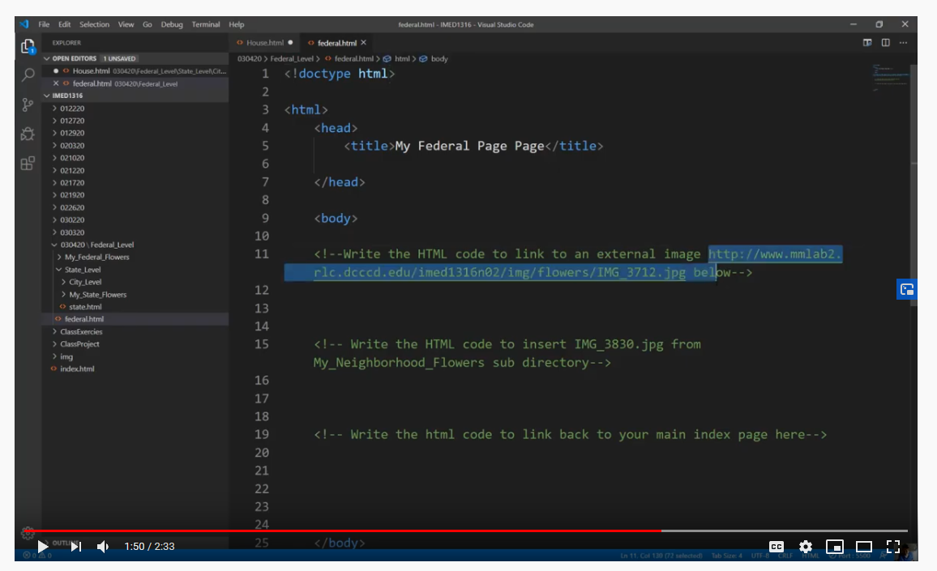

Correct link is:

<http://www.mmlab2.rlc.dcccd.edu/faculty/dao/img/IMG_3712.jpg>

1. You will need to download the **Federal_Level.zip** file from eCampus > Class Exercises > Class Exercise #4 folder. Depending on your web browsers, you will need to access this compressed file and uncompressed it.

2. Please create a subdirectory with today’s date, similar to the other dates your have created, i.e. 030322, 040521, etc… the number is arbitrary or subject to change for the semester.

3. **VERY IMPORTANT STEP** - Mounting the **Federal_Level sub directory** under the today’s date that you create from step #2. Copy the **Federal_Level sub directory** where you uncompressed the file, and paste the **Fed_Level sub directory** under today’s date folder. Looks like this:

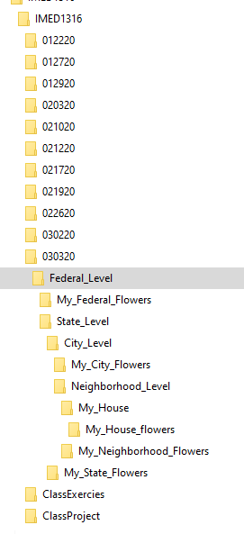

Plus the main index.html, not shown here. NOTE: the Federal_Level sub directory is indented to the right and under today’s date folder (i.e. 030320 sub directory).

NOTE: Before you move forward to the next step. Please make sure you have the proper file structure.

4. Inside every sub directory contains two sub directories and a html file.

For instance, the Federal_Level has:

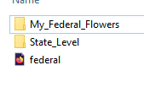

My_Federal_Flowers sub directory contains an image, the federal.html file is where you will write the HTML code. The State_Level sub directory contains another set of two sub directories and state.html file.

If I expand all of the sub directories and files in Windows Explorer, looks like this:

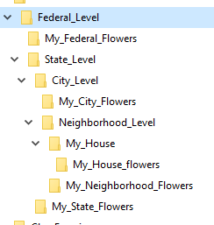

Please take a moment to review the content of these sub directories, and note the indentation of the sub directories and html files. If you collapse each of the sub directories, you can see the indentation and relationships between the files and sub directories.

**ALERT**: Please **DO NOT** move or rename any of the images in sub directories, if you do, you will forfeit this assignment.

5. Open Visual Studio Code, and Open Folder at the level of IMED1316 sub directory with it’s content:

If you expand all the content of the Federal_Level sub directory, it will look like this:

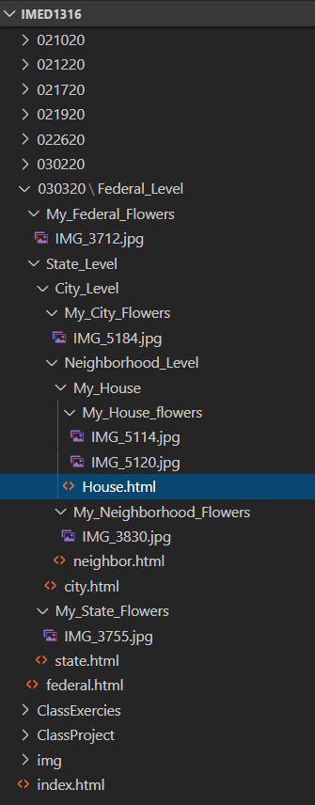

6. You task is to complete all five html file with the appropriate code under each of the comments.

**federal.html**, **state.html**, **city.html**, **neighborhood.html**, **House.html,** and update your **main index.html** to all five of these file.

7. After you complete all **six html files**, please upload the .html files and the whole file structure to the appropriate sub directory on the web server.

---------------------------------------------------------------------------------------------------------------------------------------

**Task B: HTML Links Colours and Bookmark**

File Path and Links – Part 4 <https://www.youtube.com/watch?v=J_WbjdtZwIM>

File Path and Links – Part 5 <https://www.youtube.com/watch?v=lvbwru6WsQI>

By default, a link will appear (in all browsers):

* An unvisited link is underlined and blue
* A visited link is underlined and purple
* An active link is underlined and red

The default colours in for hyperlinks, assuming the user hasn't changed their preferences, are: standard link: #0000EE (blue) visited link: #551A8B (purple) active link: #EE0000 (red).

You can change the default colours, by using CSS:

1. Under today’s date sub directory, create **links.html** file.

2. Watch this video:

3. Link the link.html page to the main index.html, and from index page to link.html page.

NOTE: There’s no screen shots for this task.

---------------------------------------------------------------------------------------------------------------------------------------

**RECAP**:

After you watch all segments and complete all Tasks A and B, Your last task for task is to update your current index web page with the content we currently complete for this week, please refer to the course syllabi schedule to assistance. You need to include the follow to the index.html.

* Link to Class Exercise #4 from your index page with a new tab open (recall target = “_blank”).
* Make sure all links work before I grade, points will be deducted for broken links.
* All webpage from this assignment must be link to and from the index.html.
* For the rest of the semester, we will be using Visual Studio Code, please do not use Notepad or any other Text Editor for this course.

**Please copy and paste your webpage URL in browser below:**

**(NOTE: Please do not copy and paste your local drive path, recalled that I provided this URL with your FTP account information)**

**https://www.mmlab2.rlc.dcccd.edu/imed1416-83840/web8520/**

**And**

**Please upload this document to eCampus > Submit All Assignment Here > Class Exercise #4 Submit Here** before due date!

Thanks, Dan.